L. J. PARTHENOS AND SON PTY LTD.
FRESH PRODUCE MERCHANTS.

MONTHLY FRESH
PRODUCE
NEWSLETTER

FEBRUARY
2026

L. J. PARTHENOS AND SON PTY LTD FRESH PRODUCE MERCHANTS IS A MEMBER OF THE L J PARTHENOS FAMILY GROUP HLD.

L. J. Parthenos and Son Pty Ltd
FEBRUARY 2026

Fruit.
- Passion fruit prices are very REASONABLE.
- All Melon prices are down, and seedless watermelon price will be fine this week.
- Fresh local Finger Limes are in good supply.
- USA Pomegranates have finished.
- Grapes have now good supply.
- Citrus fruit is still high with produce still arriving from the USA.
- New Season Apples, Pears. Will start soon.
- Fresh Dragon fruit white and red will now slow in supply.
- Fresh Valencia Oranges are excellent, and Limited Yuzu fruit.
- Lime prices will continue to be slightly up..
- Rhubarb is extra class.
- Blueberries, and strawberry prices are high, and Raspberries will remain low.
- Stone fruits season will begin to slow by next month.
- Mandarins are sensational from th USA

- Lemon prices this week will still be HIGHER levels.

- Green Pawpaw is a great option and green mangoes supply is increasing for green stock.
- Summer Mangoes still going well and readily are available.
- Avocado prices will be stable and will continue into next week.
- Pineapples stock this week will remain at higher levels.
- Pink and Yellow grapefruit are very high in price for USA fruit.
- Fig prices will be excellent this week and will continue quality is also sensational.
- Black berries are sensational, and prices are stable.
- Growing region for strawberries will be from Vic, Sth Aust fruit also.

The SUMMER season has been travelling very well, so keep me informed of your needs for new stock to supply you and with any relevant issue that may confronted us over the next few weeks NB. The consistent weather recently has had an excellent effect on all produce supply and quality we are now coming out of a Summer environment and some lines will benefit greatly.

Vegetables
- Shemiji, Oyster, baby Ilingi, will be in good supply and Brown mushrooms are improving in supply Extra Large Field Mushrooms. Direct access to VIC growers is sensational.
- Heirloom radishes please enquire first as supply is inconsistent.
- Regular iceberg and large Cos are great in price I have begun a new crop of Qld. Stock.
- New season Kale, Tuscan, and new product red butter and baby red baby cos.
- Hard produce prices for all pumpkins and all potatoes lines are still high in price and will continue.
- Snow peas, prices are still high in price Sugar snaps will stabilize.
- Zucchini flower supplies will be sensational over the next week and will continue further.
- Long red chilli prices have dropped to good levels.
- All hydro lettuces, baby cos heart supply is improving prices and will drop further.
- Australian Asparagus crops have ended and we now look to imported stocks.
- Vine ripened trays and truss prices have dropped, quality is excellent and Roma’s and Rounds are slightly up in price.
- Spring onions are very good in supply Shallots; Pickling Onions are beautiful, imported Black Garlic is still on.
- Veg lines have eased in price such as Red Capsicums and will continue to lower in price, and yellow caps will still be high.
- Chinese veg Hong Kong Choy Sum, Gai lum Sum, Mon Bok, On Choy will improve. .
- Bean handpicked and Snake beans, Roman beans HAVE begun PRICES are reasonable and the QUALITY IS GOOD. Broad Beans very scarse

New Loose Leaves 23 new varieties now available from our warehouse call me for info

- BABY EURO LEAF MIXED SALAD PREPARED BY LEO DAILY MUST BE MADE TO ORDER BY LEO IS POSING A SMALL ISSUE REGARDING VARIETY OF LEAVES THIS WILL IMPROVE
- Root veg e.g. Fennel baby only and Parsnips, Celeriac, Leek are coming in and numbers will continue.
- Pencil leeks, Target Beets have improved in supply this week, large Golden Beets are in an easier situation.
- Caulies prices are high in price this week and Eggplant are down in price.
- Baby veg is better in supply and quality is excellent availability this week will continue improve as will Heirloom baby tomatoes.
- English Spinach, Silver beet and now Rainbow chard, Finesse and Frieze heads are in good supply this week however prices remain high.

Herbs & Specialty.

- Australian N.T seedless grapes are excellent.
- All herb lines will be excellent this week into next week.
- Heirloom tomatoes have dropped numbers as has the variety levels.
- Baby Heirlooms, Vine Ripened, Ox hearts prices are up in price I have improving supply of extra-large Italian D’jura Ox tomatoes.
- Petite Bouche Exotic Leaves, please note I have an excellent supply of loose leaves.
- Seedless Watermelon price, other melon varieties will be down in price except for Honey Dew, they are slightly up.
- Baby herb lines are excellent, and all other herb lines are stable and with the higher temperature levels will affect some lines
- Chinese veg quality and availability needs to be assessed daily though quality is reasonable.
- Horseradish will be in low supply and the quality is poor.
- Navel Oranges Ruby Grapefruit prices are very high for imported USA fruit.
- Fig price is excellent, and availability is excellent season will go well into March 2026
- Heirloom baby Radishes are better in supply.
- Cherry and grape tomatoes both loose and cherry truss prices are reasonable.
- All loose-leaf delicate lines will improve with moderate temperatures.

Summer Season for all BERRIES is continuing.
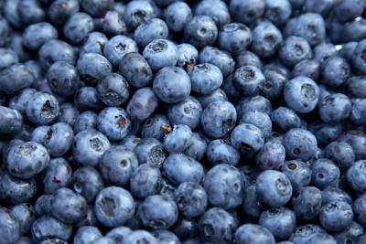

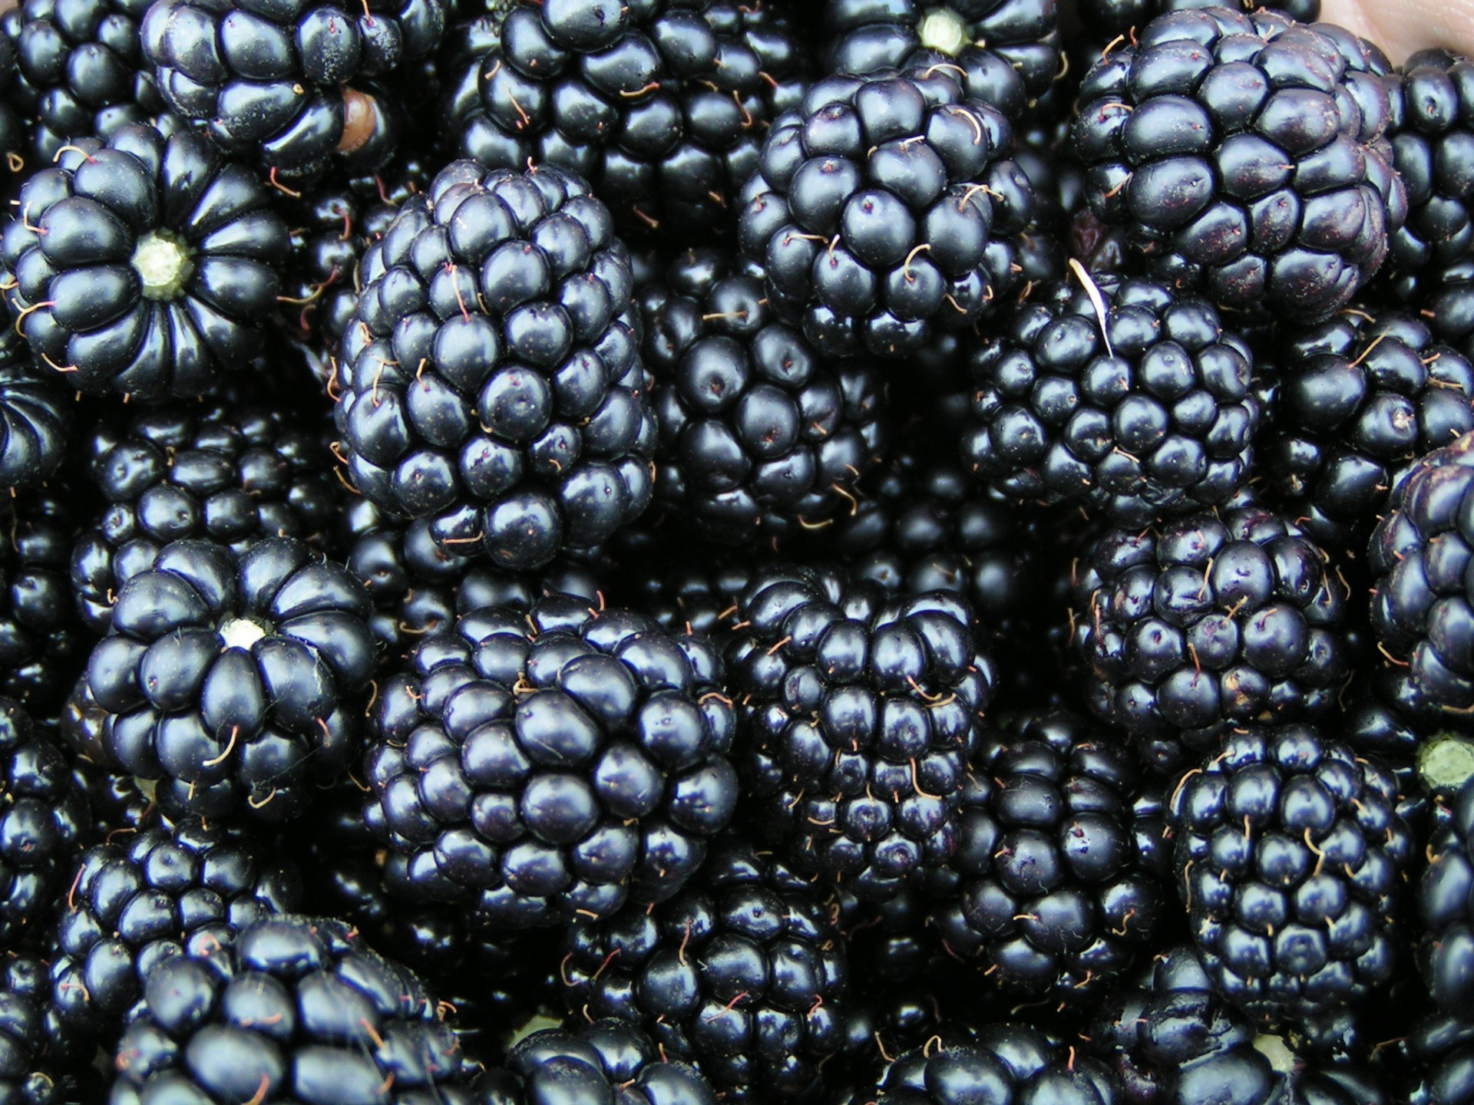

NEW SEASON TASMANIAN BLACKBERRIES

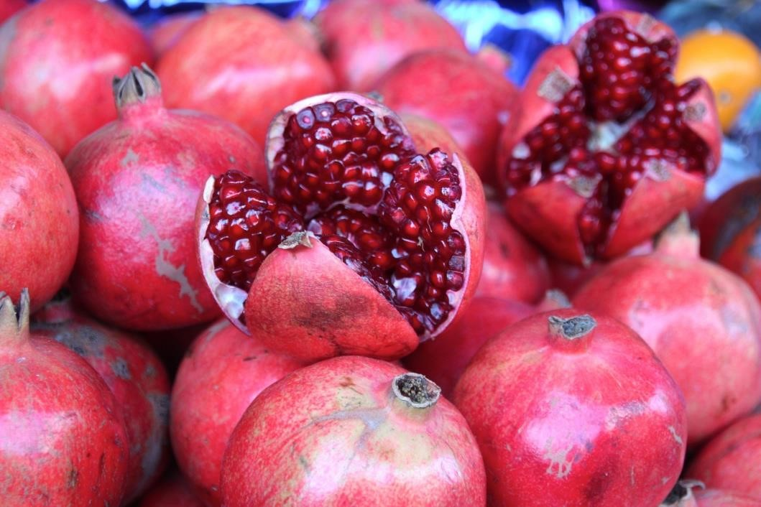
Fresh Local pomegranates very soon

GLAMOUR HEIRLOOM TOMATOES WILL BE IN LOW SUPPLY THIS WEEK AND INTO NEXTWEEK

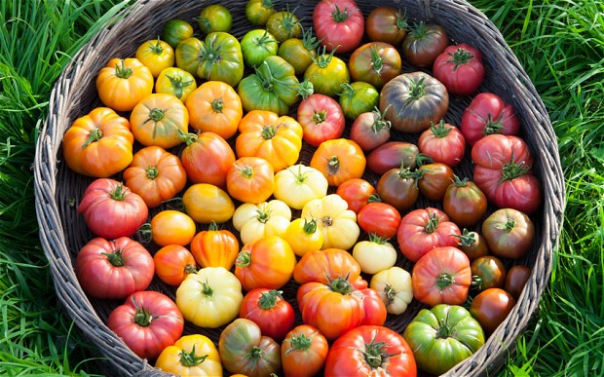


Raspberry prices are stable this week

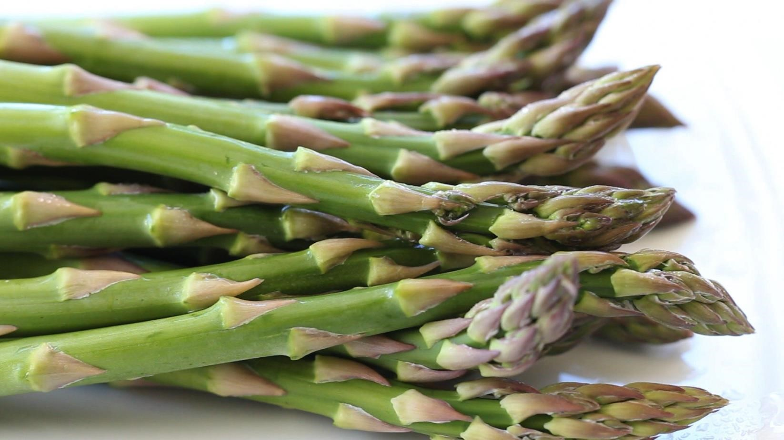

IMPORTED Green Asparagus

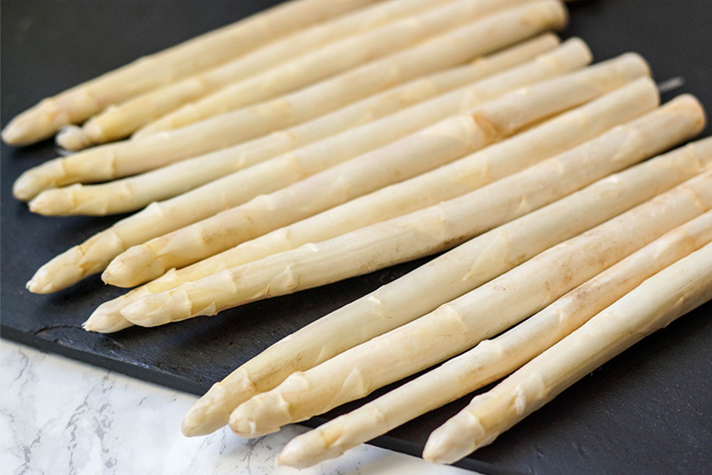

AUSTRALIAN WHITE ASPARAGUS TOO FAR AWAY MAYBE SOME IMPORTED STOCK.

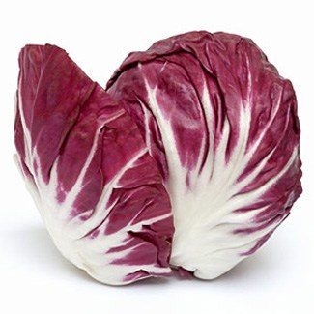
RADICCHIO HEARTS STILL SENSATIONAL
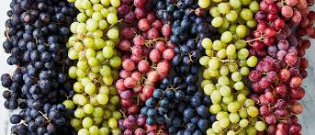
ALL VARIETIES OF SEEDLESS GRAPES ARE SENSATIONAL

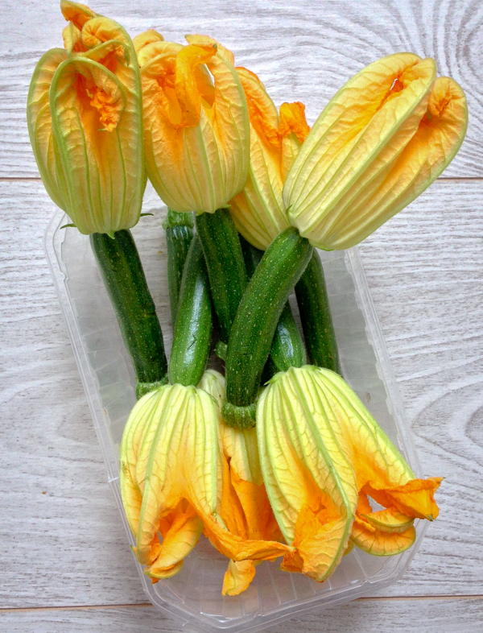
EXCELLENT SUPPLY ZUCCINI FLOWERS QUALITY IS GOOD

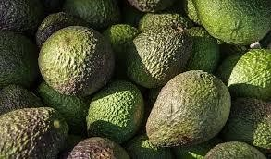

SENSATIONAL ASS AVOCADOS

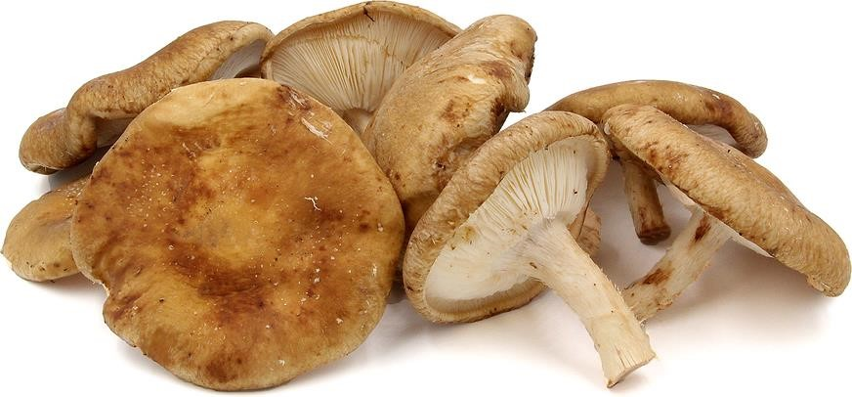
Lions-mane, Huon Valley Shiitake, Black pearl, Blue oyster, White oyster, Maitake (very limited), Snowflake Sensational

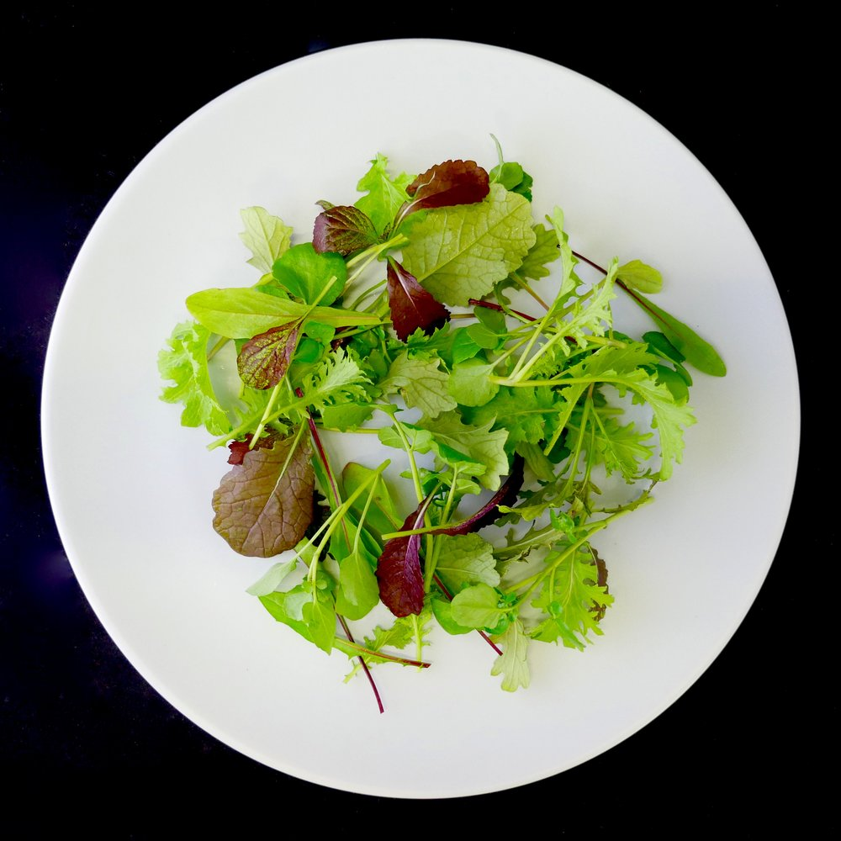
SENSATIONAL SEASONAL EURO MIX LEAF DESIGNED BY LEO PARTHENOS AND MADE TO YOUR INDIVIDUAL RECIPE

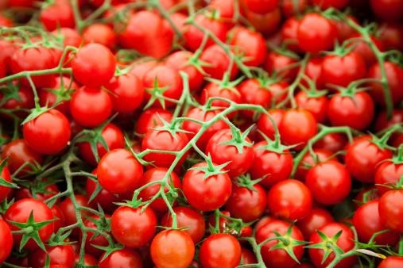
CHERRY TRUSS ARE GEWTTING BETTER BUT PRICES ARE DROPPING

EDIBLE FLOWERS ARE IN VERY LOW SUPPLY


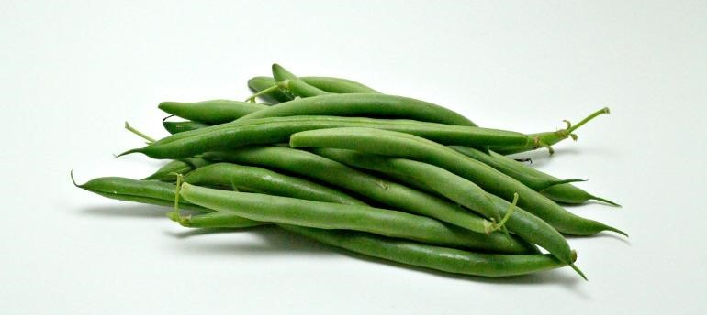
BLACK BUNTER BEANS SUPPLY IS IMPROVING

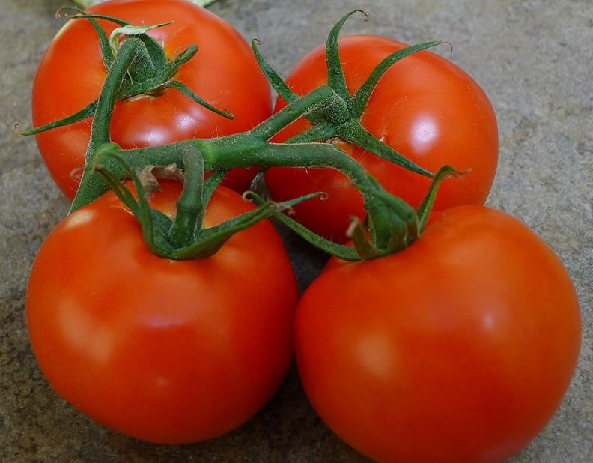
CLASSIC FIELD RIPPENED TRUSS TOMATOES

SALSIFY ROOT BLACK AND WHITE AND FERMENTED GARLIC

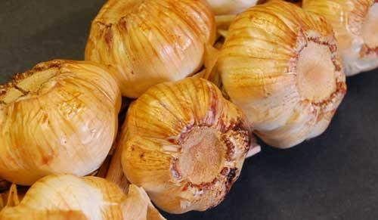

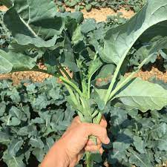
SPIGARELLO VERY LIMITED ARRIVING SOON

AUSTRALIAN BLACK GARLIC
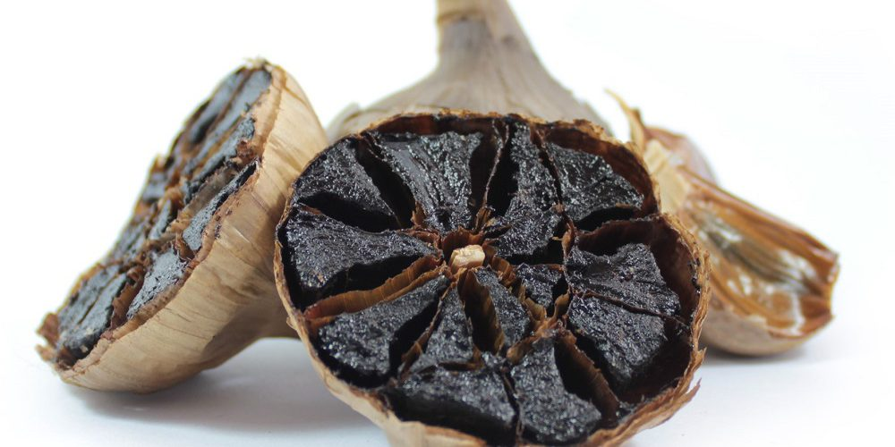

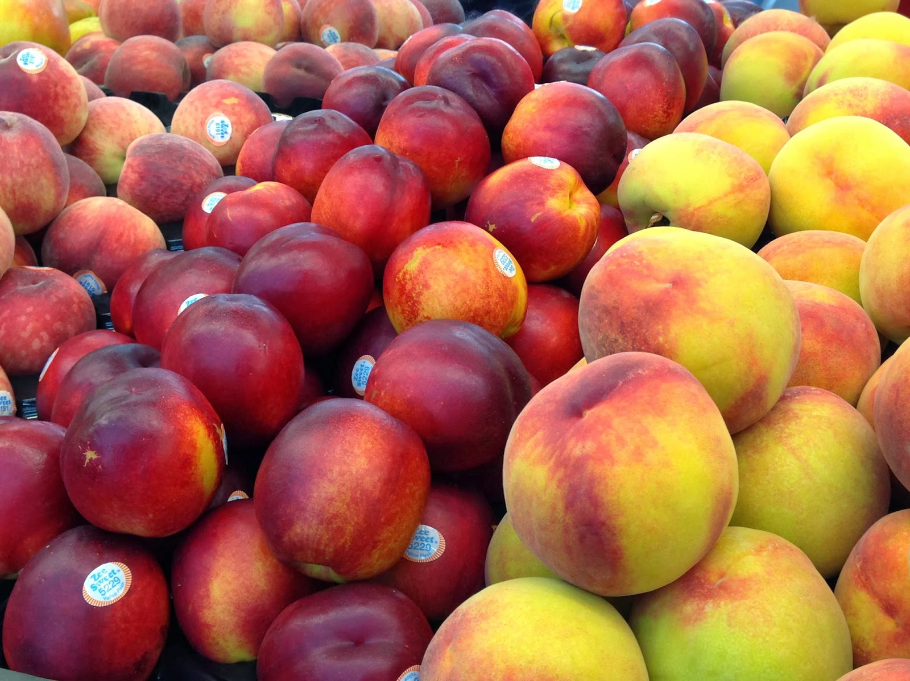

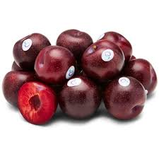

Please call me to discuss AUSTRALIAN Stone fruit produce and any special needs which refer to menu changes, availability and pricing

L. J. PARTHENOS AND SON
PTY LTD.
FRESH PRODUCE MERCHANTS.

FRESH
PRODUCE
SPREADSHEET

FEBRUARY 2026

L. J. PARTHENOS AND SON PTY LTD FRESH PRODUCE MERCHANTS IS A MEMBER OF THE PARTHENOS FAMILY GROUP HLD.

Please read the chart below for a quick guide to produce.
FRUIT | VARIETY | MARKET STATUS | PRICE QUOTE
Apples | Golden Delicious | NEW SEASON SOON
 | KANZI | “
 | Granny Smith | “
 | Fuji | “
 | Braeburn | “
 | Pink Lady | “
 | Royal Gala | “
 | JAZZ | “
Apricots |  | FINISHING
Bananas |  | PRICES HAVE STABILISED | ***
Berries | Blackberry | EXCELLENT
 | Blueberry | HAVE JUMPED UP IN PRICE | ***
 | Boysenberry | NO
 | Gooseberry | SOON
 | Raspberry | PRICE IS EXCELLENT
 | Strawberry | PRICES ARE LITTLE HIGH | ***
 | Mulberry | NO
 | Youngberry | NO
Cherries |  | SEASON HAS ONE MORE WEEK
Dates |  | EXCELLENT USA PRODUCT
Figs |  | SEASON EXCELLENT
Grapes | Black | EXCELLENT
VICTORIAN PRODUCE THIS WEEK | Red | EXCELLENT.
 | Dried | EXCELLENT
 | Muscatels | YES
 | Sultana | THOMPSON SEEDLESS
Grapefruit | White | GOOD SUPPLY | ***
 | Pink | PRICE IS HIGH | ***
Kiwifruit |  | PRICE IS VERY HIGH | ***
Lemons |  | PRICE IS STILL HIGH | ***
Limes |  | I HAVE 3 GRADES TO SUIT | ***
Lychees |  | IMPORTED NOW
Mandarins |  | FRUIT IS ISENSATIONAL | ***
Mangoes |  | SEASON IS CONTINUING
Melons | Honeydew | DOWN IN PRICE
 | Rockmelon | DOWN IN PRICE
 | Champagne | INCONSISTENT

 | Watermelon | EXCELLEWNT QUALITY PRICE IS EXCELLENT
Nectarines |  | SEASON WILL FINISH SOON | ***
Oranges | Navel | FRUIT IS EXCELLENT FROM USA | ***
 | Valencia | SEEDLESS EXCELLENT | ***
 | Blood | SEASON FINISHED
Papaya |  | EXCELLENT QUALITY
Paw Paw |  | Top Buy
Passionfruit |  | PRICE IS ACCEPTABLE | ***
Peaches | Clingstone | SEASON WILL END SOON | ***
 | Slipstone | NO | ***
LOCAL STONE FRUIT TO START FINISHING SOON
Pears | Nashi | EXCELLENT
 | Beurre Bosc | EXCELLENT
 | Corella | NEW SEASON | ***
 | Packham | EXELLENT | ***
 | HONEY GOLD | AVAILABLE
 | Sensation | NOT A GOOD OPTION
 | COCKTAIL | GOOD SUPPLY
Pineapples |  | SUPPLY IS IMPROVING
Plums | President | LARGE FRUIT ONLY
 | Blood | SOME AVAILABLE | ***
 | Autumn Giants | NO
Quinces |  | NEW SEASON
Rhubarb |  | EXCELLENT | ***
Tamarillos |  | VERY LIMITED TO NOTHING
Tangellos |  | EXCELLENT
VEGETABLES
Alfafa | Sprouts | 8 different varieties | ***
Artichoke | Globe | NEXT MONTH
 | Jerusalem | SEASON BEGINNING NEXT MONTH
Asparagus | Green | IMPORTED
 | Purple | NO
 | White | AVAILABLE SOON BUT INCONSISTENT
Avocado |  | THE PRICES WILL BE STABLE | ***
Beans | Beanettes | PRICE ARE DOWN | ****
 | Borlotti | GOOD SUPPLY SUPPLY
 | Broad | SEASON IS OVER
 | Butter | GOOD THIS WEEK | *****
 | Flat | ROMAN BEANS ARE EXCELLENT SUPPLY | *****
 | Green | EXCELLENT PRODUCT | ***
 | Snake | EXCELLENT NT | ***

Beetroot | Large | TOP BUY | ***
 | Baby | EXCELLENT | ***
Broccoli | Heads | PRICE IS RESONABLE | ***
Brocollini |  | EXCELLENT | ***
Brussell Sprouts |  | VERY HIGH PRICE FROM W/AUST | ***
Cabbage | Green | PRICES EXCELLENT
 | Red | PRICES EXCELLENT
 | Savoy | SENSATIONAL EURO SAVOY PRICE IS EXCELLENT
 | Chinese | PRICE IS STABLE | ***
Capsicum | Green | PRICE IS ACCEPTABLE | ***
 | Red | PRICE IS DROPPING | ***
 | Yellow | EXCELLENT BUT HIGH IN PRICE | ***
Carrots | Large/Medium | TASSY PRODUCT IS  OUTSTANDING PRICE REASONABLE
 | Baby | EXCELLENT | ***
Cauliflower |  | PRICE THIS WEEK WILL BE HIGH HEADS ARE EXCELLENT | ***
Celery |  | PRICE IS LOW | ***
Celeriac |  | QUALITY IS EXCELLENT
Corn | Sweet | SUPPLY THIS WEEK IS HIGH AND PRCES ARE EXCELLENT
 | Baby | Always a good choice
Cucumbers | Green | APPLE CUES ARE JUST OK
 | Lebanese | PRICES STILL STABLE | ***
 | Telegraph | PRICES EASING | ***
Eggplant | Medium | PRICES ARE EXCELLENT | ***
 | Baby/Japanese | EXCELLENT | ***
Escallots | French | EXCELLENT SUPPLY | ***
Fennel |  | BABY BETTER SUPPLY NOW | ***
Kohlrabi |  | SUPPLY IS FAIR
Leek | Medium | EXCELLENT PRODUCT | ***
 | Pencil/Finger | EXCELLENT | ***
Lettuce | Butter | IMPROVING | ***
 | Cos/Baby | IMPROVING | ***
 | Coral - Red/Green | IMPROVING | ***
 | Oak - Red/Green | IMPROVING | ***
 | Iceberg | QUALITY IS EXCELLENT | ***
 | Mignonette | IMPROVING | ***
 | Endive | EXCELLENT QUALITY | ***
 | Mache | BE CAREFUL | ***
 | Radicchio | VERY LOW SUPPLY

 | Tatsoi | RECEIVING BETTER PRODUCT | ***
 |  |  | ***
MUSHROOM UPDATE | Button | PRICE HAS STABILIZED | ***
AVAILABILITY OF ALL TYPES OF MUSHROOMS | Cup | PRICE HAS STABILIZED | ***
WILL IMPROVE THIS WEEK. | Flat | PRICE HAS STABILIZED | ***
 | Swiss Brown | IMPROVING SUPPLY | ***
BETTER SUPPLY OF BUTTONS AND FLATS | Shitake | TASMANIAN WILD ASIAN VARIETY | ***
 | Black/White Funghi | YES | ***
 | Wild/Forest | EXOTIC EXCELLENT QUALITY PINES SOON
 | Enoki | YES | ***
 | Oyster - W/P/Y | BETTER SUPPLY | ***
 | Shemeji | BETTER BLACK AND WHITE | ***
 | Portobello | GOOD SUPPLY | ***
FOREST MUSHROOM | PINE | PINES TO SHOW SOON
Okra |  | WILL BE GOOD IN SUPPLY
Onions | Brown | PRICE IS LOW
 | Spanish | TOP BUY
 | Pickling | YES
 | White | PRICE IS UP
 | Spring | IMPROVING | ***
Parsnips |  | PRICES ARE STILL UP
ALL LARGE DESERIE POTATOES PRICES ARE VERY HIGH STILL | New | UP IN PRICE | ***
A GREAT DEAL OF SUPPLY AND | Cocktail | EXCELLENT | ***
QUALITY DRAMA DUE TO DESEADED PRODUCE | Desiree | ALL DESERIE POTATO PRICES ARE HIGH | ***
BUT IT IS IMPROVING | Pontiac | EXCELLENT | ***
 | Buntje | EXCELLENT | ***
 | Kipfler | PRICE IS DOWN | ***
 | Pink Eye | YES | ***
 | Purple Congo | PURPLE BLISS AND CONGO SOON | ***
 | Pink Fur | YES
 | Dutch Cream | YES, AND EXTRA LARGE ALSO | ***
 | Russet Burbank | YES
 | Rosevals | NO
 | Spunta/Nicola | NO
 | Sweet/Kumera | EXCELLENT IN PRICE
 | Sebagos | IMPROVING | ***
 | Andian Gold | NEXT WEEK
 |  |  | ***
Peas | Green | EXTREMELY GOOD QUALITY

 | Snow | PRICES HAVE RISEN | ***
 | Sugar Snap | PRICES HAVE DROPPED | ***
Pumpkin | Butternut | REASONABLE PRICED PRODUCT
 | Queensland Blue | GREAT PRICE RIGHT NOW
 | Golden Nugget | VERY EXPENSIVE
 | Jap | PRICE IS IMPROVING
Radish | White/Daikon | BETTER
 | Red | EXCELLENT ALL SIZES | ***
 | Horse | BETTER QUALITY
Spinach | English | PRICE HAS JUMPED | ***
 | Silverbeet | PRICES ARE HIGH THIS WEEK | ***
Squash | Green | SHORT
 | Yellow | PRICE IS HIGH
Swedes |  | NEW CROP I WOULD WAIT
TOMATOES
ALL TOMATOES ARE EXCELLENT IN QUALITY BUT SOME PRICES ARE HOLDING LOW STILL | Round | PRICES ARE EASING | ***
 | Cherry | BETTER PRICE THIS WEEK | ***
 | Teardrop | VERY GOOD | ***
 | Roma | PRICES ARE REASONABLE | ***
 | Vine Ripened | PRICES ARE LOW | ***
 | Black Crimson | LOW SUPPLY | ***
 | Ox Tomato | ITALIAN OX HEART SUPPLY IS FAIR | ***
Turnips | Medium | NEW CROP JUST STARTED TODAY
 | Baby | BETTER
Whitlof | Green | BETTER SUPPLY
 | Red | BETTER SUPPLY
Zucchini | Green | PRICES ARE REASONABLE | ***
 | Yellow | LIMITED | ***
 | Flowers | PRODUCT QUALITY IS  IMPROVING SUPPLY IS  EXCELLENT | ***
ASIAN
Bean Shoots |  | BETTER
Banana Leaf |  | BETTER SUPPLY
Bok Choy | Bunch | EXCELLENT | ***
 | Baby | TRAYS ARE FANTASTIC | ***
Choy Sum |  | EXCELLENT | ***
 |  |  | ***
Chinese Broccoli |  | EXCELLENT

Curry Leaf |  | VERY LIGHT AND LOW SUPPLY | ***
Galangal |  | GREAT | ***
Vine Leaf |  | YES BUT LIMITED | ***
ON CHOY | LOOSE | EXCELLENT | ***
MIXES
Mescalin |  | YES | ***
Asian Mix |  | YES | ***
Cress Mix |  | YES | ***
Baby Spinach |  | EXCELLENT | ***
Wild Roquette |  | SUPPLY IS EXCELLENT | ***
Baby Roquette |  | EXCELLENT | ***
Mizuna |  | BETTER | ***
Finesse |  | EXCELLENT | ***
Baby Tatsoi |  | BETTER | ***
Snow Pea Leaf |  | WILL BE OKAY | ***
HERBS
Basil | Green | SENSATIONAL QUALITY | ***
 | Purple | PLEASE ASK FOR DETAILS | ***
 | Thai | BETTER SUPPLY | ***
Bay |  | GOOD SUPPLY THIS WEEK | ***
Chervil |  | QUALITY IS BETTER SUPPLY IS OKAY | ***
Chives | Green | EXCELLENT | ***
 | Garlic | GREAT PRODUCT | ***
 | White | SLOWLY FILTERING THROUGH | ***
Chicory |  | VERY GOOD SUPPLY | ***
Chillies | Birdseye | BETTER PRICE NOW | ***
 | Green | YES | ***
 | Long Red/Green | PRICE IS IMPROVING | ***
Parsley | Continental | VERY GOOD QUALITY | ***
 | Curly | PRICE IS HIGH | ***
Coriander |  | VERY LOW SUPPLY | ***
Tarragon |  | FRENCH IS VERY GOOD BUT HIGH IN PRICE | ***
 |  |  | ***
Dill |  | BETTER SUPPLY
Garlic |  | TOP MARKET BUY | ***
Ginger |  | LOW SUPPLY THIS WEEK | ***
Finger Limes |  | FRESH AND ROZEN ALSO | ***
Lime Leaf |  | HIGH PRICE | ***
Peppercorn |  | SOON
SORREL |  | IMPROVING
INDIVIDUAL PRODUCE AVAILABILITY
AND PRICE ENVIORMENT
FOR THE MONTH
ALSO LOOK AT LAST COLOUMN FOR
** * FOR CHEAP BUYING AND GOOD
AVAILABILITY THROUGH THE REST OF SUMMER

STOP THE PRESS:

PLEASE CALL OR EMAIL ME REGARDING THE FOLLOWING SEASONAL ITEMS

BLOOD ORANGES FINISHED

ALL VARIETIES OF EGGPLANT

AUSTRALIAN STONE FRUIT

SENSATIONAL RAINBOW CHARD

JERUSALEM ARTICHOKES SOON

L. J. Parthenos and Son Pty Ltd
FEBRUARY 2026

QUICK SNAPSOT

Produce Projections for the next Period: Market produce will be affected in price by recent weather please make enquiries.

Raspberries are at better levels Strawberries and Blueberries are easing.

Tomato price will be at GOOD levels and Roma tomatoes will also be at GOOD levels.

Passion fruit is excellent,

Lemon prices are HIGH, and navel Oranges, Pink Grapefruit and Pomelo supply is IMPORTED.

Handpicked Roman Beans high in price but the quality is good.

Improved quantity of root veg is available, all varieties are improving.

Stone fruit supply is from AUSTRALIAN crops very GOOD STILL

Fresh Salsify EXCELLENT Horse radish is improving in availability.

Mushrooms crops are improving Swiss brown and Portobello are inconsistent and the Korean product is excellent and Chestnut variety is excellent, but Buttons are improving.

Baby herbs are excellent quality this week even with current hot conditions.

All brushed Sebago Potatoes have jumped in price with regional Qld. Now finishing

All red chillies this week will be a good price for red colour and there is some 2nd grade.

Chats Cocktail potatoes are reasonable for good Sth Australian produce.

Herb produce lines pricing will reflect the better weather moving in

LEO’S TOP BUYING FOR NOVEMBER 2025

THE FOLLOWING ITEMS ARE TO BE CONSIDERED

- PLUMS STILL FROM LOCAL PRODUCERS

- ENGLISH SPINACH AND SILVER BEET QUALITY AND PRICES ARE UP

- EXCELLENT SUPPLY OF CITRUS FRUIT, NAVELS, VALENCIA, MANDARINS, GRAPEFRUIT

- MOST ROOT VEGE LINES, EG. GOLD BEETS HAVE IMPROVED IN SUPPLY.

- MANGOES ARE IN BETTER SUPPLY AND ARE EXCELLENT

- EXTRA CLASS LOCAL SUPPLY AUSTRALIAN GARLIC HAS BEGUN

ALL VARIETIES OF APPLES ARE GOOD, NEW SEASON SPRING VARIETIES HEAR NOW.

- EDIBLE FLOWERS WILL STRUGGLE WITH THIS HEAT

- FIGS ARE EXCELLENT IN PRICE WITH FRUIT WITH EXCELLENT SUPPLY

- EXTRA CLASS HEIRLOOM CHERRY TOMATOES AND BLACK ZEBERINOS VARIETIES PRICES ARE HIGH AND LOW SUPPLY ATM.

- SPECIAL LETTUCE AND LOOSE-LEAF LINES MUST BE LOOKED AT DAILY.

- LEBANESE CUE AND BABY CUES ARE DROPPING IN PRICE. ALSO, VARIETIES OF ASIAN PRODUCE WILL SLOW IN SUPPLY DUE TO RECENT LOW TEMPERATURES ENQUIRE DAILY.

- TOP QUALITY NEW SEASON PRODUCTS ARE AVAILABLE PLEASE CALL ASAP

- LARGE FENNEL IS STRUGGLING THIS WEEK BABY IS EXCELLENT.

- CHEAP LINES LIMES, IN STOCK THIS WEEK. YUZU FRUIT AND LEMONADE FRUIT IS FINISHED

- SOME PRODUCT PRICES HAVE BEEN DRIVEN DOWN DUE TO LOW DEMAND

N.B. ALL CITRUS WILL BE FROM CALIF GROWING REGIONS THIS WEEK

LEO’S CRITICAL ISSUES FOR NOVEMBER 2025

PLEASE CALL ME REGARDING THE FOLLOWING ITEMS LISTED BELOW
- Baby Fennel will be better in supply, baby root veg’s, including heirloom carrots will improve.
- Prices for SPRING baby veg this week will be GREAT for this week.
- Tomatoes prices for roma will be OKAY for coloured fruit.
- Zucchini flowers are EXCELLENT, and actual zucchinis are down in price.
- Local leaf produce is slowly finding its way through, weather was moderate.
- All Pears are sensational.
- Roman Beans continuing to be better and will be reasonable in price this week.
- Broccolini supply will be good this week and Broccoli prices have DROPPED considerably.
- Fig AVAILABILITY IS EXCELLENT FOR NEXT WEEK NEW SEASON NEARLY HERE.
- Asparagus Green supply is low this week prices will be high
- Leek prices have stabilised in price.
- Cavolo Nero, Mizuna, Red Vein Sorrel, has improved this week.
- All citrus lines will be expensive, and lemons will continue to be up for the rest of the week
- All red coloured chillies jumped in price this week; long greens are DOWN in price.
- Celery Leeks, and Caps are DOWN in pricing AS WELL AS cauliflower in price.
- Butternut Pumpkin excellent quality as is Regular Jap and Qld the price is DOWN.
- Strawberries prices are up, and Blueberries, prices are also up in price.
- Blackberries and Raspberries prices are down in price.

This week’s considerations for the following: Be cautious conditions in all growing regions with summerseason still hanging in.

- Avocado numbers are increasing, and prices are stable refer all sales to me directly.
- Most veg prices stabilised.
- Lemon price levels will be high again this week.
- Grapes are outstanding the price levels are good, fruit from VICTORIA
- Loose leaf produce is EXCELLENT.
- Cos and Iceberg lettuce quality is good, but prices will be a little HIGH.
- Edible flowers supply this week and next week will struggle.
- Herb lines this month will be struggling as weather temperatures are down
Some SPRING Fruit lines will now begin, Call me please.
- Some SPRING Veg especially, produce from the QLD regions will come to Sydney.
- Bananas are reasonable in price be very cautious when ordering.
- SENSATIONAL NEW SEASON SPRING PRODUCE NOW AVAILABLE.

Consider these items also for this week.

ALL STRAWBERRIES

YELLOW AND GREEN BEANS ARE IMPROVING

CITRUS IS BEING IMPORTED FROM O/S

AUSTRALIAN GROWN HEIRLOOM CHERRY TOMATOES

Black Ivory lettuce excellent

Qld. limes CALL ME as this is a critical issue.

Heirloom toms Black Kumato, Medley

AUST. STONE FRUIT WHITE AND YELLOW NECTARINES AND PEACHES

MANGOES SENSATIONAL FOR NOW WITH HONEY GOLD BEING THE PICK

EXTRA LARGE EGGPLANT

LYCHEE SEASON WILL BE AVAILABLE FROM O/S

New Season large Heirloom GREEN TOMATOES EXCELLENT

PLUMS AUSTRALIAN STILL HANGING IN

