L. J. PARTHENOS AND SON PTY LTD.
FRESH PRODUCE MERCHANTS.

MONTHLY FRESH
PRODUCE
NEWSLETTER

SPRING
2026

L. J. PARTHENOS AND SON PTY LTD FRESH PRODUCE MERCHANTS IS A MEMBER OF THE L J PARTHENOS FAMILY GROUP HLD.

L. J. Parthenos and Son Pty Ltd
SPRING 2026

Fruit.
- Passion fruit prices are very REASONABLE.
- All Melon prices are falling, and seedless watermelon price will be fine this week.
- Fresh local Finger Limes are in low supply.
- USA Pomegranates crops are excellent.
- Grapes have now good supply from USA expect prices to be HIGH.
- Citrus fruit from QLD. S.A. NSW. And VIC Excellent and improving.
- All Apples and corella, Packham, nashi Pears are easing.
- Fresh Dragon fruit white and red will now slow in supply.
- Fresh Valencia Oranges are excellent, and Lemonade finishing soon.
- Lime prices will continue to be at high prices.
- Rhubarb is extra class.
- Blueberries, and strawberry prices are improving, and Raspberries will remain low.
- Stone fruits season is now from USA, Aust soon.
- Mandarins are sensational.

- Lemon prices this week will be at excellent levels.

- Green Pawpaw is a great option and green mangoes supply is increasing for green stock.
- NT AUSTRALIAN Mangoes are available.
- Avocado prices will be RISING and will continue into next week.
- Pineapples stock this week will remain at good levels.
- Pink and Yellow grapefruit are down in price.
- Fig prices will be high this week and will continue quality is also down.
- Black berries are sensational, and prices are stable.
- Growing region for strawberries will be from Qld and some USA fruit also.

The Spring season will begin this week, so keep me informed of your needs for new stock to supply you and with any relevant issue that may confronted us over the next few weeks NB. The consistent weather recently has had an excellent effect on all produce supply and quality we are now coming out of an unstable environment and some lines will benefit greatly.

Vegetables
- Shemiji, Oyster, baby Ilingi, will be in good supply and Brown mushrooms are improving in supply Extra Large Field Mushrooms. Direct access to VIC growers is sensational.
- Heirloom radishes please enquire first as supply is consistent.
- Regular iceberg and large Cos are great in price I have begun a new crop of Qld. Stock.
- New season Kale, Tuscan, and new product red butter and baby red baby cos.
- Hard produce prices for all pumpkins and all potatoes lines are low in price and will continue.
- Snow peas, Peas prices will be good in price Sugar snaps will stabilize.
- Zucchini flower supplies will be sensational over the next week and will continue further.
- Long red chilli prices have dropped to good levels.
- All hydro lettuces, baby cos heart supply is improving prices and will drop further.
- Australian Asparagus crops will be in full swing soon, I will let you know when its close
- Vine ripened trays and truss prices have dropped quality is excellent and Roma’s and Rounds have lowered in price.
- Spring onions are very good in supply Shallots; Pickling Onions are beautiful, imported Black Garlic is still on.
- Veg lines have eased in price such as Red Capsicums and will continue to be low in price, and yellow caps will still be high.
- Chinese veg Hong Kong Choy Sum, Gai lum Sum, Mon Bok, On Choy will improve.
- Bean handpicked and Snake beans, Roman beans HAVE begun PRICES are reasonable and the QUALITY IS GOOD. Broad Beans soon.

New Loose Leaves 23 new varieties now available from our warehouse call me for info

- BABY EURO LEAF MIXED SALAD PREPARED BY LEO DAILY MUST BE MADE TO ORDER BY LEO IS POSING A SMALL ISSUE REGARDING VARIETY OF LEAVES THIS WILL IMPROVE
- Root veg e.g. Fennel baby only and Parsnips, Celeriac, Leek are coming in and numbers will continue.
- Pencil leeks, Target Beets have improved in supply this week, large Golden Beets are in an easier situation.
- Caulies prices are down in price this week and Eggplant are down in price.
- Baby veg is better in supply and quality is excellent availability this week will continue improve as will Heirloom baby tomatoes.
- English Spinach, Silver beet and now Rainbow chard, Finesse and Frieze heads are in good supply this week.

Herbs & Specialty.

- USA seedless grapes are excellent.
- All herb lines will be excellent this week into next week.
- Heirloom tomatoes have risen to great numbers and variety levels are excellent.
- Baby Heirlooms, Vine Ripened, Ox hearts prices are down in price I have improving supply of extra-large heirloom tomatoes.
- Petite Bouche Exotic Leaves, please note I have an excellent supply of loose leaves.
- Seedless Watermelon price, other melon varieties will be down in price except for Honey Dew, they are slightly up.
- Baby herb lines are excellent, and all other herb lines are stable with the higher temperature weather.
- Chinese veg quality and availability needs to be assessed daily though quality is reasonable.
- Horseradish will be in better supply, and the quality is really good.
- Navel Oranges Ruby Grapefruit prices are very good.
- Fig price is high, and availability is low, season will begin again in the end of November and go well into March 2026
- Heirloom baby Radishes are better in supply.
- Cherry and grape tomatoes both loose and cherry truss prices are reasonable.
- All loose-leaf delicate lines will improve with moderate temperatures.

What's in Spring Season is coming excellent BLUEBERRIES.
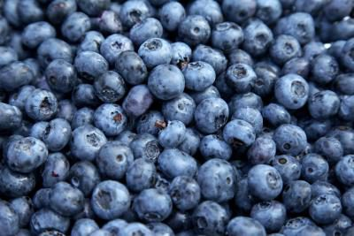

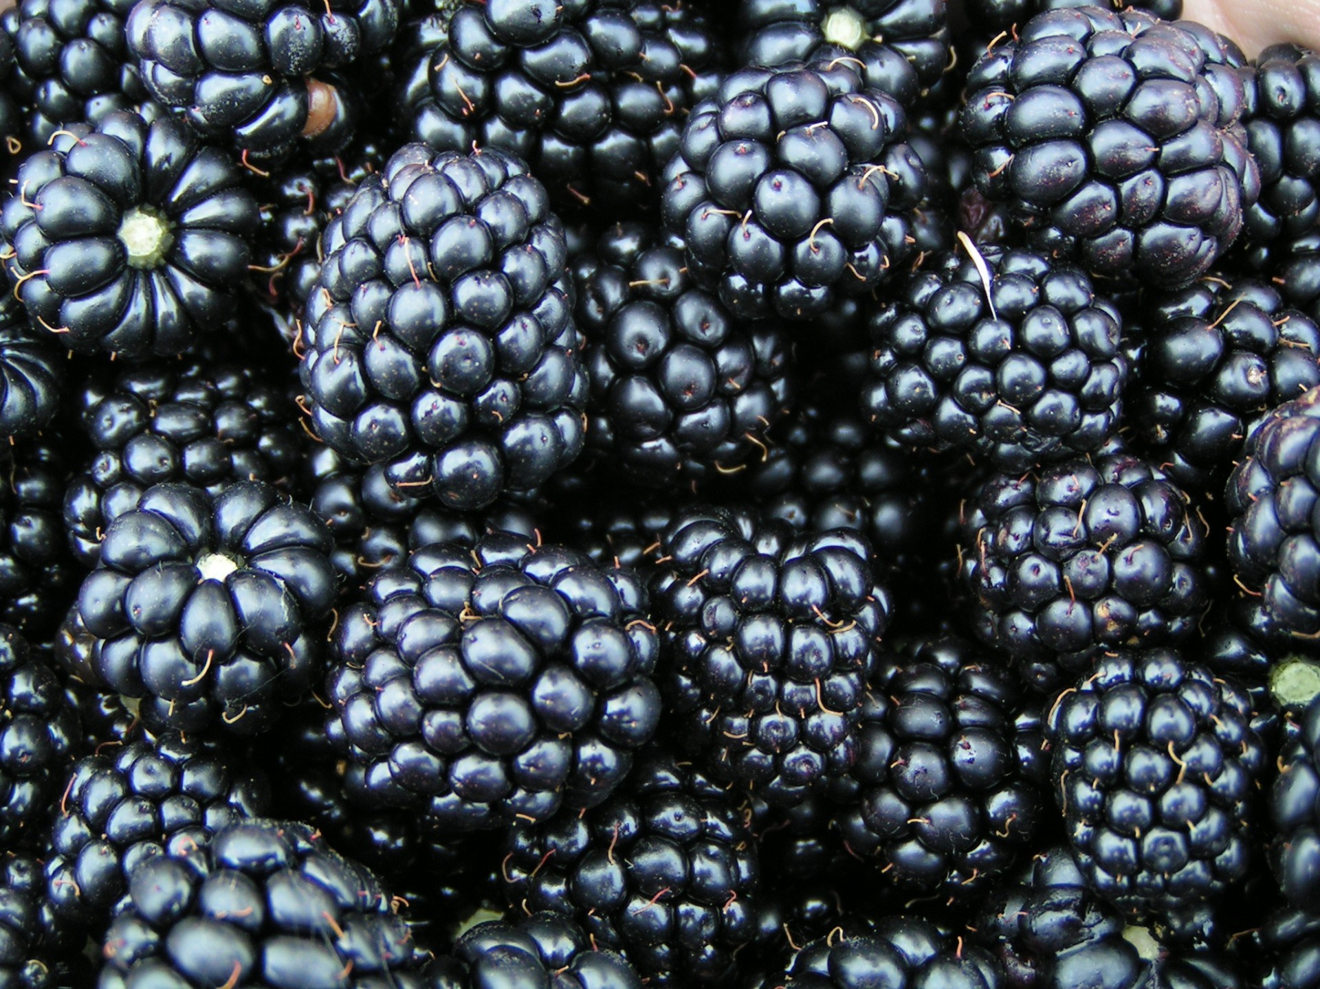

NEW SEASON BLACKBERRIES

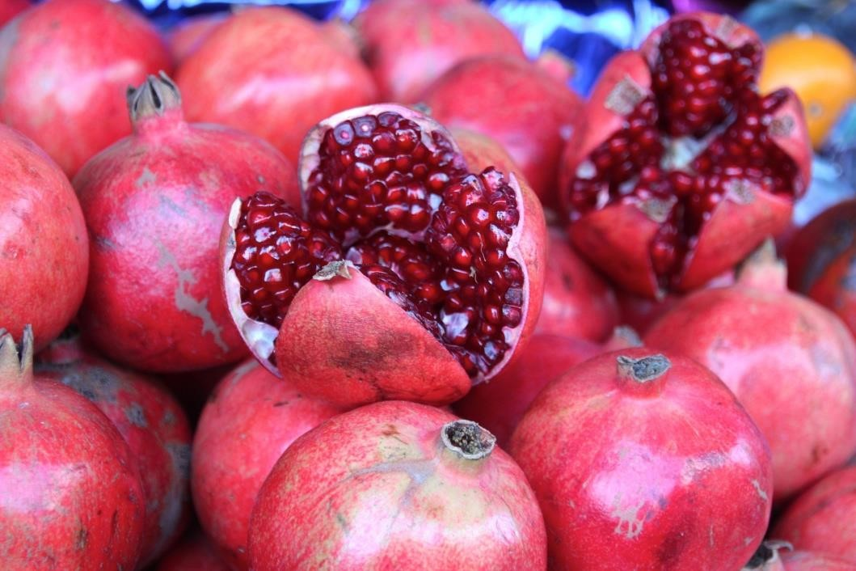
Fresh USA pomegranates

GLAMOUR HEIRLOOM TOMATOES IS EXCELLENT THIS WEEK AND INTO NEXTWEEK

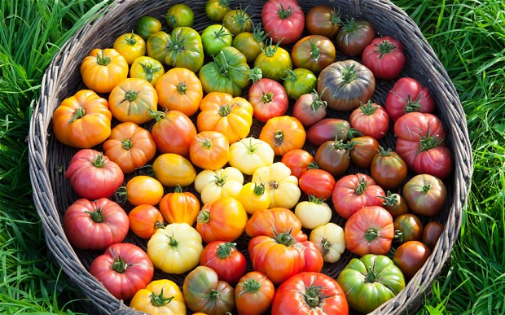


Raspberry prices are stable this week

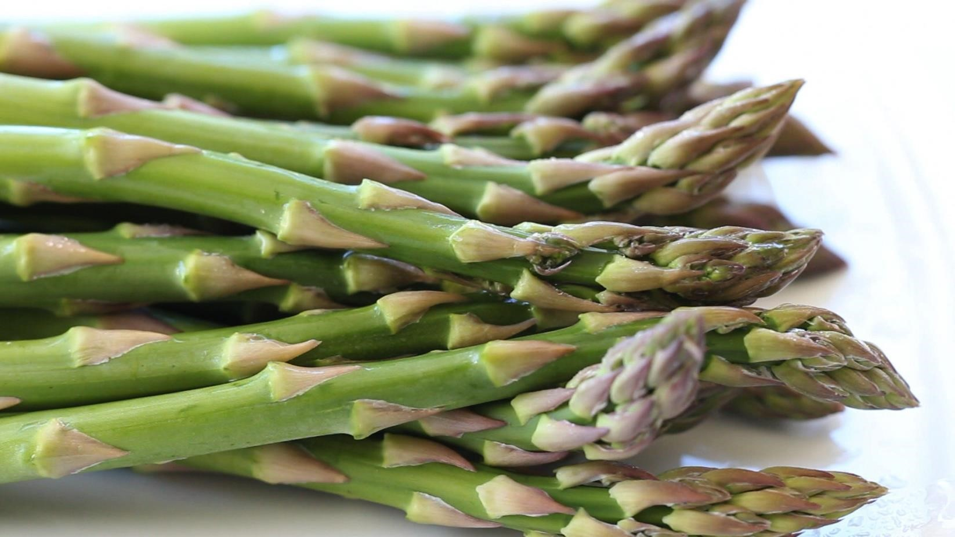

Australian Green Asparagus

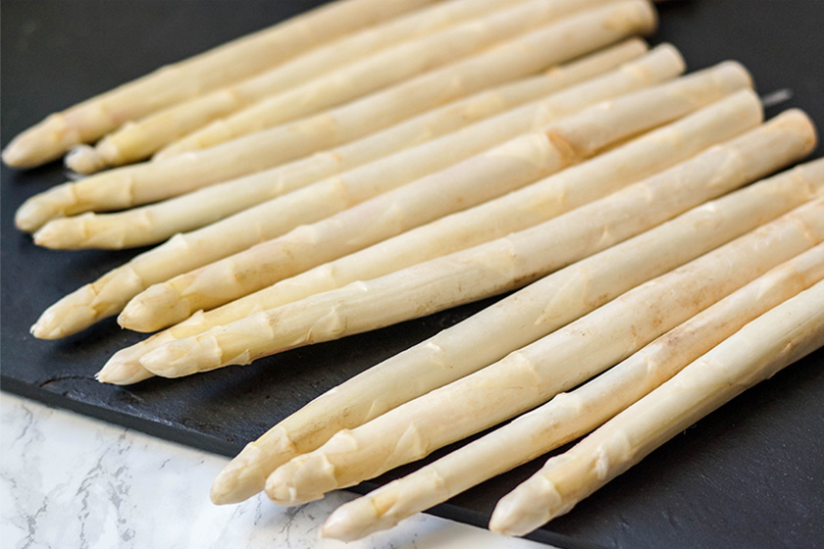

TASMANIAN WHITE ASPARAGUS SOON

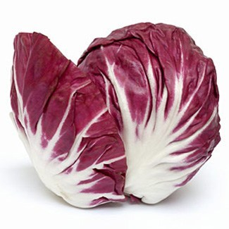
RADICCHIO HEARTS ARE SENSATIONAL
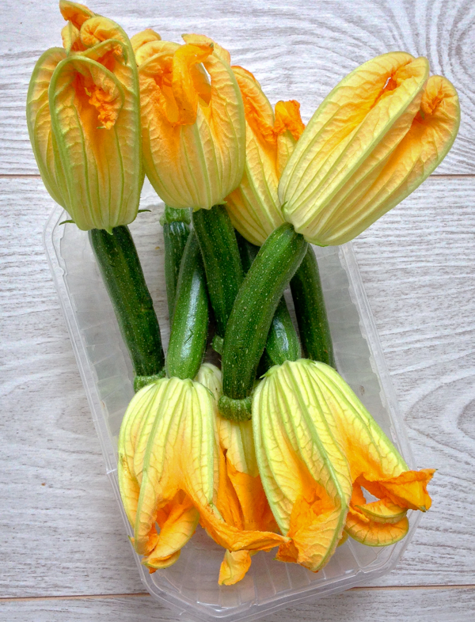
LIMITED SUPPLY ZUCCINI FLOWERS QUALITY IS GOOD

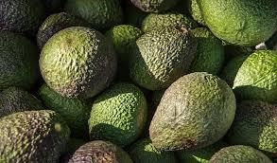

Hass Avocados prices, SENSATIONAL

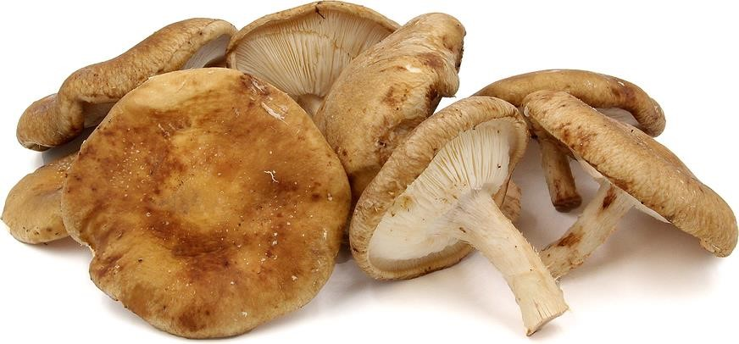
Lions-mane, Huon Valley Shiitake, Black pearl, Blue oyster, White oyster, Maitake (very limited), Snowflake Sensational

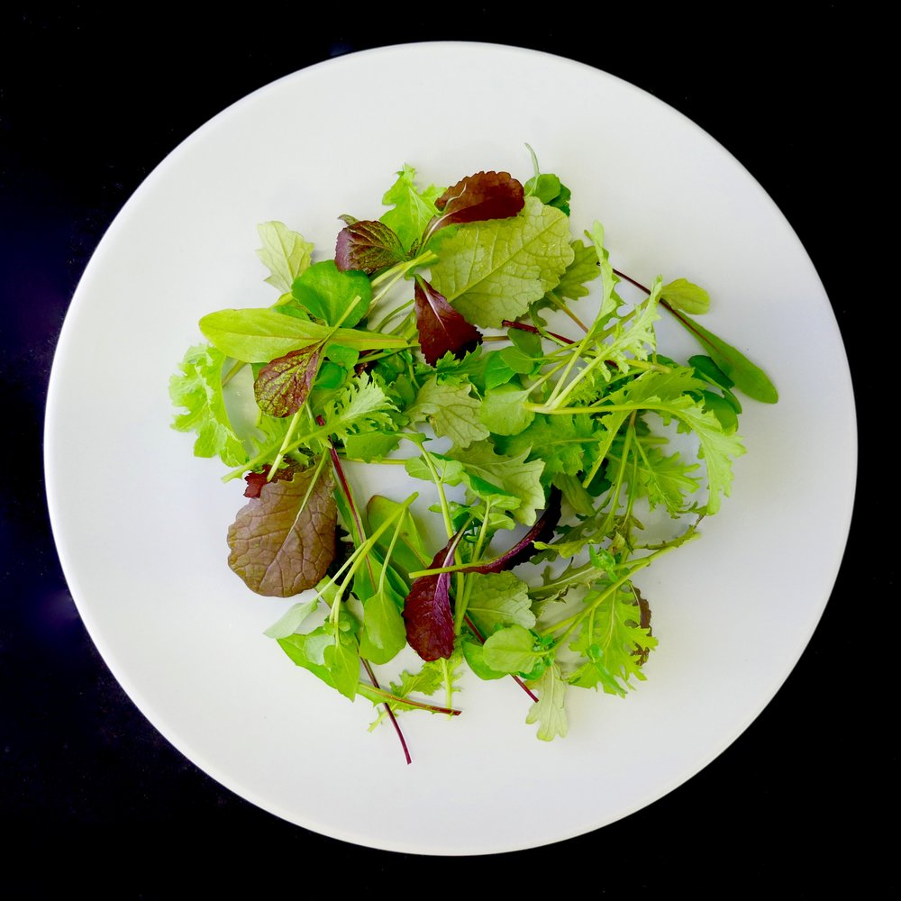
SENSATIONAL SEASONAL EURO MIX LEAF DESIGNED BY LEO PARTHENOS AND MADE TO YOUR INDIVIDUAL RECIPE

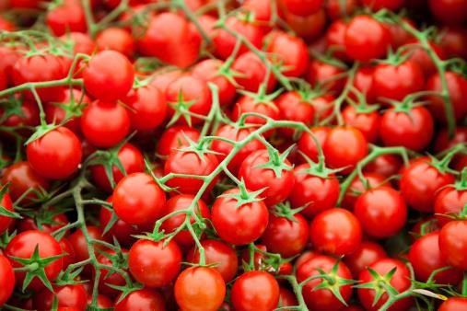
CHERRY TRUSS ARE GEWTTING BETTER BUT PRICES ARE DROPPING
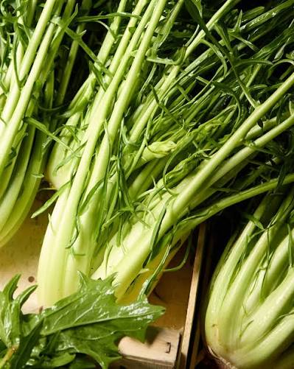
SENSATIONAL PUNTARELLA AVAILABLE THIS WEEK

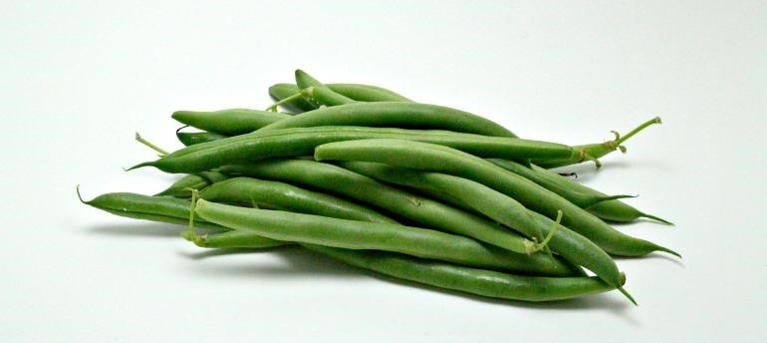
BLACK BUNTER BEANS SUPPLY IS IMPROVING

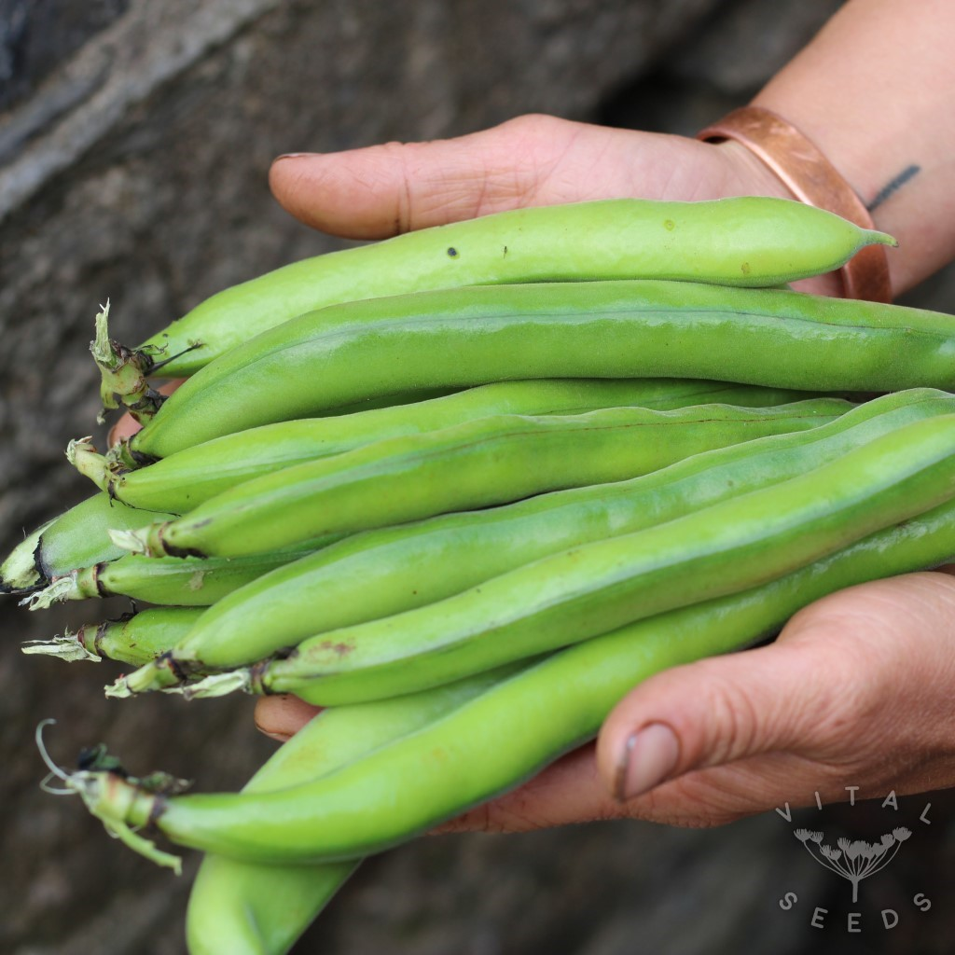

SPRING SEASON BROAD BEANS NOW IN FULL SWING

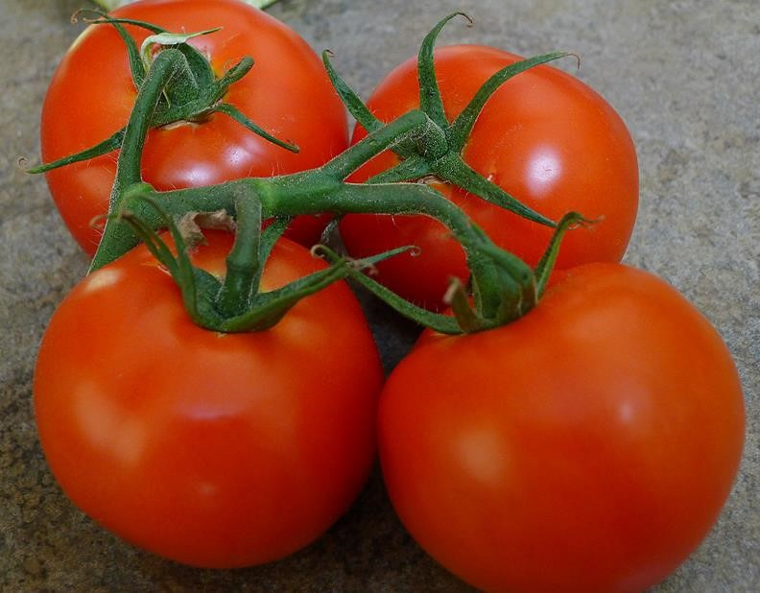

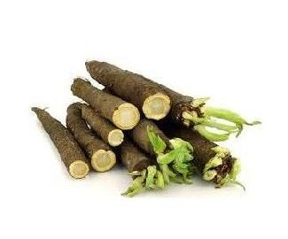SALSIFY ROOT BLACK AND WHITE

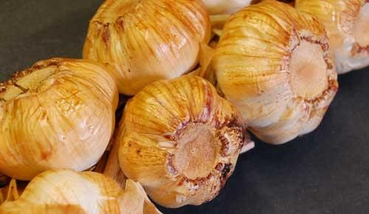

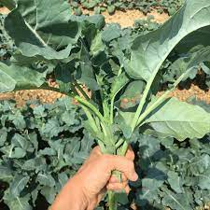
SPIGARELLO VERY LIMITED ARRIVING

SMOKED GARLIC AND BLACK GARLIC
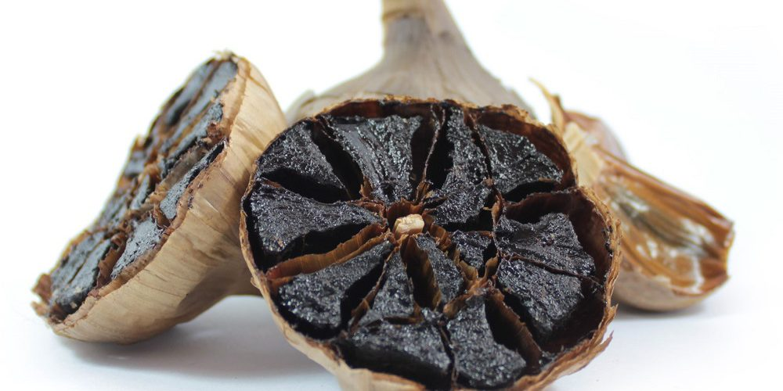

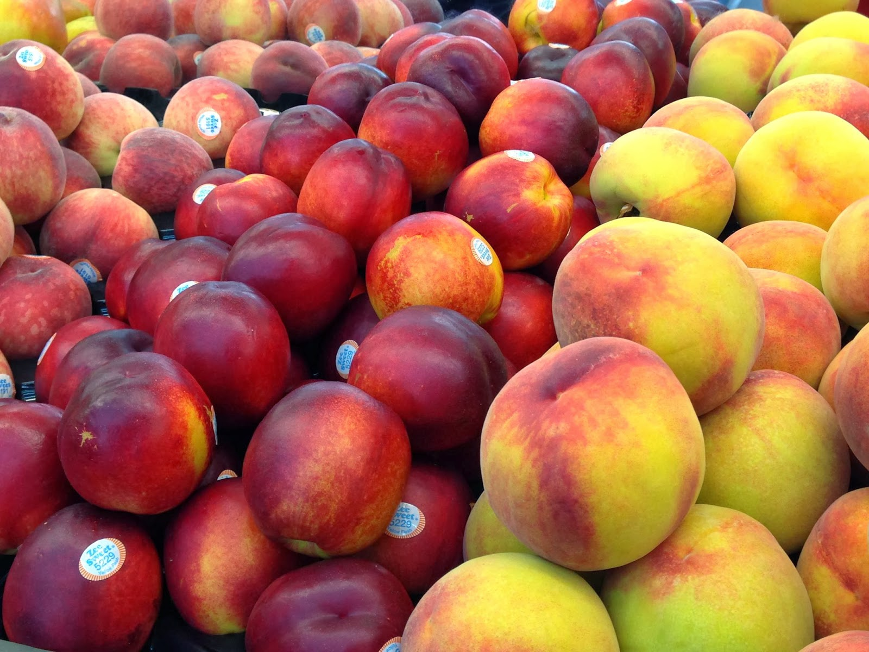

Please call me to discuss CALIFORNIAN Stone fruit produce and any special needs which refer to menu changes, availability and pricing

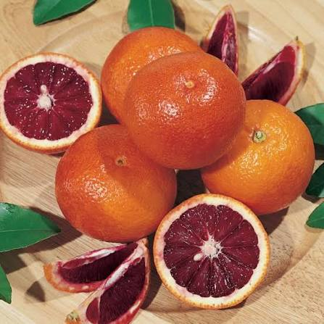

BLOOD ORANGES TO CONTINUE THROUGH SEPTEMBER

L. J. PARTHENOS AND SON
PTY LTD.
FRESH PRODUCE MERCHANTS.

FRESH
PRODUCE
SPREADSHEET

SPRING 2026

L. J. PARTHENOS AND SON PTY LTD FRESH PRODUCE MERCHANTS IS A MEMBER OF THE PARTHENOS FAMILY GROUP HLD.

Please read the chart below for a quick guide to produce.
FRUIT | VARIETY | MARKET STATUS | PRICE QUOTE
Apples | Golden Delicious | ALL VARIETIES EXCELLENT
 | KANZI | “
 | Granny Smith | “
 | Fuji | “
 | Braeburn | “
 | Pink Lady | “
 | Royal Gala | “
 | JAZZ | “
Apricots |  | SOON
Bananas |  | PRICES HAVE STABILISED | ***
Berries | Blackberry | EXCELLENT
 | Blueberry | HAVE DROPPED IN PRICE | ***
 | Boysenberry | NO
 | Gooseberry | YES
 | Raspberry | PRICE IS EXCELLENT
 | Strawberry | PRICES ARE DOWN | ***
 | Mulberry | FINISHED
 | Youngberry | NO
Cherries |  | USA SEASON
Dates |  | EXCELLENT USA PRODUCT
Figs |  | SEASON SLOW
Grapes | Black | EXCELLENT
USA PRODUCE THIS WEEK | Red | EXCELLENT.
 | Dried | EXCELLENT
 | Muscatels | YES
 | Sultana | THOMPSON SEEDLESS
Grapefruit | White | GOOD SUPPLY | ***
 | Pink | PRICE IS IMPROVING | ***
Kiwifruit |  | IMPROVING | ***
Lemons |  | PRICE IS EXCELLENT | ***
Limes |  | I HAVE 3 GRADES TO SUIT | ***
Lychees |  | NO IMPORTED ONLY
Mandarins |  | FRUIT IS ISENSATIONAL | ***
Mangoes |  | SEASON IS BEGINING
Melons | Honeydew | DOWN IN PRICE
 | Rockmelon | DOWN IN PRICE
 | Champagne | INCONSISTENT

 | Watermelon | EXCELLEWNT QUALITY PRICE IS EXCELLENT
Nectarines |  | USA SEASON SOON | ***
Oranges | Navel | FRUIT IS EXCELLENT FROM VICTORIA NSW | ***
 | Valencia | SEEDLESS EXCELLENT | ***
 | Blood | SENSATIONAL
Papaya |  | EXCELLENT QUALITY
Paw Paw |  | Top Buy
Passionfruit |  | PRICE IS ACCEPTABLE | ***
Peaches | Clingstone | USA SEASON | ***
 | Slipstone | NO | ***
LOCAL STONE FRUIT TO START SOON
Pears | Nashi | EXCELLENT
 | Beurre Bosc | EXCELLENT
 | Corella | NEW SEASON | ***
 | Packham | EXELLENT | ***
 | HONEY GOLD | AVAILABLE
 | Sensation | NOT A GOOD OPTION
 | COCKTAIL | VERY LOW SUPPLY
Pineapples |  | SUPPLY IS IMPROVING
Plums | President | USA FRUIT ONLY
 | Blood | NOT AVAILABLE | ***
 | Autumn Giants | NO
Quinces |  | NO
Rhubarb |  | EXCELLENT | ***
Tamarillos |  | VERY LIMITED TO NOTHING
Tangellos |  | EXCELLENT
VEGETABLES
Alfafa | Sprouts | 8 different varieties | ***
Artichoke | Globe | EXCELLENT
 | Jerusalem | SEASON BEGINNING TO SLOW
Asparagus | Green | IMPORTED AND AUST
 | Purple | NO
 | White | AVAILABLE SOON BUT INCONSISTENT
Avocado |  | THE PRICES WILL BE STABLE | ***
Beans | Beanettes | PRICE ARE DOWN | ****
 | Borlotti | GOOD SUPPLY SUPPLY
 | Broad | SEASON HAS BEGUN
 | Butter | GOOD THIS WEEK | *****
 | Flat | ROMAN BEANS ARE EXCELLENT SUPPLY | *****
 | Green | EXCELLENT PRODUCT | ***
 | Snake | EXCELLENT NT | ***

Beetroot | Large | TOP BUY | ***
 | Baby | EXCELLENT | ***
Broccoli | Heads | PRICE IS RESONABLE | ***
Brocollini |  | EXCELLENT | ***
Brussell Sprouts |  | REASONABLE SUPPLY AND PURPLE | ***
Cabbage | Green | PRICES EXCELLENT
 | Red | PRICES EXCELLENT
 | Savoy | SENSATIONAL EURO SAVOY PRICE IS EXCELLENT
 | Chinese | PRICE IS STABLE | ***
Capsicum | Green | PRICE IS ACCEPTABLE | ***
 | Red | PRICE IS EXCELLENT | ***
 | Yellow | EXCELLENT BUT HIGH IN PRICE | ***
Carrots | Large/Medium | TASSY PRODUCT IS  OUTSTANDING PRICE REASONABLE
 | Baby | EXCELLENT | ***
Cauliflower |  | PRICE THIS WEEK WILL BE HIGH HEADS ARE EXCELLENT | ***
Celery |  | PRICE IS LOW | ***
Celeriac |  | QUALITY IS EXCELLENT
Corn | Sweet | SUPPLY THIS WEEK IS LOW AND PRCES ARE HIGH
 | Baby | Always a good choice
Cucumbers | Green | APPLE CUES ARE JUST OK
 | Lebanese | PRICES STILL STABLE | ***
 | Telegraph | PRICES EASING | ***
Eggplant | Medium | PRICES ARE EXCELLENT | ***
 | Baby/Japanese | EXCELLENT | ***
Escallots | French | EXCELLENT SUPPLY | ***
Fennel |  | BABY BETTER SUPPLY NOW | ***
Kohlrabi |  | SUPPLY IS GOOD
Leek | Medium | EXCELLENT PRODUCT | ***
 | Pencil/Finger | EXCELLENT | ***
Lettuce | Butter | IMPROVING | ***
 | Cos/Baby | IMPROVING | ***
 | Coral - Red/Green | IMPROVING | ***
 | Oak - Red/Green | IMPROVING | ***
 | Iceberg | QUALITY IS EXCELLENT | ***
 | Mignonette | IMPROVING | ***
 | Endive | EXCELLENT QUALITY | ***
 | Mache | BE CAREFUL | ***
 | Radicchio | VERY GOOD SUPPLY

 | Tatsoi | RECEIVING BETTER PRODUCT | ***
 |  |  | ***
MUSHROOM UPDATE | Button | PRICE HAS STABILIZED | ***
AVAILABILITY OF ALL TYPES OF MUSHROOMS | Cup | PRICE HAS STABILIZED | ***
WILL IMPROVE THIS WEEK. | Flat | PRICE HAS STABILIZED | ***
 | Swiss Brown | IMPROVING SUPPLY | ***
BETTER SUPPLY OF BUTTONS AND FLATS | Shitake | TASMANIAN WILD ASIAN VARIETY | ***
 | Black/White Funghi | YES | ***
 | Wild/Forest | EXOTIC EXCELLENT QUALITY PINES SOON
 | Enoki | YES | ***
 | Oyster - W/P/Y | BETTER SUPPLY | ***
 | Shemeji | BETTER BLACK AND WHITE | ***
 | Portobello | GOOD SUPPLY | ***
FOREST MUSHROOM | PINE | PINES TO SHOW SOON
Okra |  | WILL BE GOOD IN SUPPLY
Onions | Brown | PRICE IS LOW
 | Spanish | TOP BUY
 | Pickling | YES
 | White | PRICE IS UP
 | Spring | IMPROVING | ***
Parsnips |  | PRICES ARE STILL UP
ALL LARGE DESERIE POTATOES PRICES ARE VERY HIGH STILL | New | UP IN PRICE | ***
A GREAT DEAL OF SUPPLY | Cocktail | EXCELLENT | ***
QUALITY IS A HUGE DRAMA | Desiree | ALL DESERIE POTATO PRICES ARE HIGH | ***
BUT IT IS IMPROVING | Pontiac | EXCELLENT | ***
 | Buntje | EXCELLENT | ***
 | Kipfler | PRICE IS DOWN | ***
 | Pink Eye | YES | ***
 | Purple Congo | PURPLE BLISS AND CONGO | ***
 | Pink Fur | YES
 | Dutch Cream | YES, AND EXTRA LARGE ALSO | ***
 | Russet Burbank | YES
 | Rosevals | YES
 | Spunta/Nicola | EXCELLENT
 | Sweet/Kumera | EXCELLENT IN PRICE
 | Sebagos | IMPROVING | ***
 | Andian Gold | NEXT WEEK
 |  |  | ***
Peas | Green | EXTREMELY GOOD QUALITY

 | Snow | PRICES HAVE DROPPED | ***
 | Sugar Snap | PRICES HAVE DROPPED | ***
Pumpkin | Butternut | REASONABLE PRICED PRODUCT
 | Queensland Blue | GREAT PRICE RIGHT NOW
 | Golden Nugget | VERY EXPENSIVE
 | Jap | PRICE IS IMPROVING
Radish | White/Daikon | BETTER
 | Red | EXCELLENT ALL SIZES | ***
 | Horse | BETTER QUALITY
Spinach | English | PRICE HAS DROPPED | ***
 | Silverbeet | PRICES ARE DOWN THIS WEEK | ***
Squash | Green | SHORT
 | Yellow | PRICE IS HIGH
Swedes |  | NEW CROP I WOULD WAIT
TOMATOES
ALL TOMATOES ARE EXCELLENT IN QUALITY BUT SOME PRICES ARE HOLDING LOW STILL | Round | PRICES ARE LOW | ***
 | Cherry | HIGH PRICE THIS WEEK | ***
 | Teardrop | VERY GOOD | ***
 | Roma | PRICES ARE LOW | ***
 | Vine Ripened | PRICES ARE LOW | ***
 | Black Crimson | IMPROVING SUPPLY | ***
 | Ox Tomato | ITALIAN OX HEART SUPPLY IS GOOD | ***
Turnips | Medium | NEW CROP JUST STARTED TODAY
 | Baby | BETTER
Whitlof | Green | BETTER SUPPLY
 | Red | BETTER SUPPLY
Zucchini | Green | PRICES ARE REASONABLE | ***
 | Yellow | LIMITED | ***
 | Flowers | PRODUCT QUALITY IS  IMPROVING SUPPLY IS  EXCELLENT | ***
ASIAN
Bean Shoots |  | BETTER
Banana Leaf |  | BETTER SUPPLY
Bok Choy | Bunch | EXCELLENT | ***
 | Baby | TRAYS ARE FANTASTIC | ***
Choy Sum |  | EXCELLENT | ***
 |  |  | ***
Chinese Broccoli |  | EXCELLENT

Curry Leaf |  | VERY LIGHT AND LOW SUPPLY | ***
Galangal |  | GREAT | ***
Vine Leaf |  | YES BUT LIMITED | ***
ON CHOY | LOOSE | EXCELLENT | ***
MIXES
Mescalin |  | YES | ***
Asian Mix |  | YES | ***
Cress Mix |  | YES | ***
Baby Spinach |  | EXCELLENT | ***
Wild Roquette |  | SUPPLY IS EXCELLENT | ***
Baby Roquette |  | EXCELLENT | ***
Mizuna |  | BETTER | ***
Finesse |  | EXCELLENT | ***
Baby Tatsoi |  | BETTER | ***
Snow Pea Leaf |  | WILL BE OKAY | ***
HERBS
Basil | Green | SENSATIONAL QUALITY | ***
 | Purple | PLEASE ASK FOR DETAILS | ***
 | Thai | BETTER SUPPLY | ***
Bay |  | GOOD SUPPLY THIS WEEK | ***
Chervil |  | QUALITY IS BETTER SUPPLY IS OKAY | ***
Chives | Green | EXCELLENT | ***
 | Garlic | GREAT PRODUCT | ***
 | White | SLOWLY FILTERING THROUGH | ***
Chicory |  | VERY GOOD SUPPLY | ***
Chillies | Birdseye | BETTER PRICE NOW | ***
 | Green | YES | ***
 | Long Red/Green | PRICE IS EXCELLENT | ***
Parsley | Continental | VERY GOOD QUALITY | ***
 | Curly | PRICE IS HIGH | ***
Coriander |  | VERY GOOD SUPPLY | ***
Tarragon |  | FRENCH IS VERY GOOD IN SUPPLY | ***
 |  |  | ***
Dill |  | BETTER SUPPLY
Garlic |  | TOP MARKET BUY | ***
Ginger |  | LOW SUPPLY THIS WEEK | ***
Finger Limes |  | FFRESH AND ROZEN ALSO | ***
Lime Leaf |  | HIGH PRICE | ***
Peppercorn |  | FINISHED
SORREL |  | IMPROVING
INDIVIDUAL PRODUCE AVAILABILITY
AND PRICE ENVIORMENT
FOR THE MONTH
ALSO LOOK AT LAST COLOUMN FOR
** * FOR CHEAP BUYING AND GOOD
AVAILABILITY THROUGH SPRING

STOP THE PRESS:

PLEASE CALL OR EMAIL ME REGARDING THE FOLLOWING SEASONAL ITEMS

BLOOD ORANGES

ALL VARIETIES OF EGGPLANT

USA STONE FRUIT

SENSATIONAL RAINBOW CHARD

JERUSALEM ARTICHOKES STILL EXCELLENT

L. J. Parthenos and Son Pty Ltd
SPRING 2026

QUICK SNAPSOT

Produce Projections for the next Period: Market produce will be affected in price by recent weather please make enquiries.

Raspberries are at better levels Strawberries and Blueberries are easing.

Tomato price will be at GOOD levels and Roma tomatoes will also be at GOOD levels.

Passion fruit is excellent,

Lemon prices are DOWN, and navel Oranges, Pink Grapefruit and Pomelo supply is IMPROVING.

Handpicked Roman Beans high in price but the quality is good.

Improved quantity of root veg is available, all varieties are improving.

Stone fruit supply is from USA crops very good quality.

Fresh Salsify EXCELLENT Horse radish is improving in availability.

Mushrooms crops are improving Swiss brown and Portobello are inconsistent and the Korean product is excellent and Chestnut variety is excellent, but Buttons are improving.

Baby herbs are excellent quality this week even with current hot conditions.

All brushed Sebago Potatoes have jumped in price with regional Qld. Now finishing

All red chillies this week will be a good price for red colour and there is some 2nd grade.

Chats Cocktail potatoes are reasonable for good Sth Australian produce.

Herb produce lines pricing will reflect the better weather moving in

LEO’S TOP BUYING FOR SEPTEMBER 2026

THE FOLLOWING ITEMS ARE TO BE CONSIDERED

- PLUMS STILL FROM USA

- ENGLISH SPINACH AND SILVER BEET QUALITY AND PRICES ARE EXCELLENT

- EXCELLENT SUPPLY OF CITRUS FRUIT, NAVELS, VALENCIA, MANDARINS, GRAPEFRUIT

- MOST ROOT VEGE LINES, EG. GOLD BEETS HAVE IMPROVED IN SUPPLY.

- NT. MANGOES ARE IN BETTER SUPPLY AND ARE EXCELLENT

- EXTRA CLASS LOCAL SUPPLY AUSTRALIAN GARLIC HAS BEGUN

ALL VARIETIES OF APPLES ARE GOOD, NEW SEASON SPRING VARIETIES HEAR NOW.

- EDIBLE FLOWERS WILL STRUGGLE WITH THIS COLD

- FIGS ARE UP IN PRICE WITH FRUIT WITH LOW SUPPLY

- EXTRA CLASS HEIRLOOM CHERRY TOMATOES AND BLACK ZEBERINOS VARIETIES PRICES ARE HIGH AND LOW SUPPLY ATM.

- SPECIAL LETTUCE AND LOOSE-LEAF LINES MUST BE LOOKED AT DAILY.

- LEBANESE CUE AND BABY CUES ARE DROPPING IN PRICE. ALSO, VARIETIES OF ASIAN PRODUCE WILL SLOW IN SUPPLY DUE TO RECENT LOW TEMPERATURES ENQUIRE DAILY.

- TOP QUALITY NEW SEASON PRODUCTS ARE AVAILABLE PLEASE CALL ASAP

- LARGE FENNEL IS IMPROVING THIS WEEK BABY IS EXCELLENT.

- CHEAP LINES LIMES, IN STOCK THIS WEEK. YUZU FRUIT AND LEMONADE FRUIT IS FINISHED

- SOME PRODUCT PRICES HAVE BEEN DRIVEN DOWN DUE TO LOW DEMAND

N.B. ALL CITRUS WILL CONITUE TO BE FROM AUSTRALIAN GROWING REGIONS

LEO’S CRITICAL ISSUES FOR SPRING 2026

PLEASE CALL ME REGARDING THE FOLLOWING ITEMS LISTED BELOW
- Baby Fennel will be better in supply, baby root veg’s, including heirloom carrots will improve.
- Prices for SPRING baby veg this week will be GREAT for this week.
- Tomatoes prices for roma will be OKAY for coloured fruit.
- Zucchini flowers are EXCELLENT, and actual zucchinis are down in price.
- Local leaf produce is slowly finding its way through, weather was moderate.
- All Pears are sensational.
- Roman Beans continuing to be better and will be reasonable in price this week.
- Broccolini supply will be good this week and Broccoli prices have DROPPED considerably.
- Fig AVAILABILITY IS LOW FOR NEXT WEEK NEW SEASON NEARLY HERE.
- Asparagus Green supply is low price this week will be high
- Leek prices have stabilised in price.
- Cavolo Nero, Mizuna, Red Vein Sorrel, has improved this week.
- All citrus lines will be reasonable, and lemons will continue to be down for the rest of the week
- All red coloured chillies jumped in price this week; long greens are DOWN in price.
- Celery Leeks, and Caps are DOWN in pricing AS WELL AS cauliflower in price.
- Butternut Pumpkin excellent quality as is Regular Jap and Qld the price is DOWN.
- Strawberries prices are down, and Blueberries, prices are also down in price.
- Blackberries and Raspberries prices are down in price.

This week’s considerations for the following: Be cautious conditions in all growing regions with SPRING season slow to begin.

- Avocado numbers are increasing, and prices are stable refer all sales to me directly.
- Most veg prices stabilised.
- Lemon price levels will be down again this week.
- Grapes are outstanding the price levels are good, fruit from USA.
- Loose leaf produce is EXCELLENT.
- Cos and Iceberg lettuce quality is good, but prices will be HIGH.
- Edible flowers supply this week and next week will struggle.
- Herb lines this month will be struggling as weather temperatures are down
Some SPRING Fruit lines will now begin, Call me please.
- Some SPRING Veg especially, produce from the QLD regions will come to Sydney.
- Bananas are reasonable in price be very cautious when ordering.
- SENSATIONAL NEW SEASON SPRING PRODUCE NOW AVAILABLE.
Consider these items also for this week.

ALL STRAWBERRIES

YELLOW AND GREEN BEANS ARE IMPROVING

LOCAL AUSTRALIAN CITRUS

AUSTRALIAN GROWN HEIRLOOM CHERRY TOMATOES

Black Ivory lettuce excellent

Qld. limes CALL ME I HAVE SOME GREAT LINES.

Heirloom toms Black Kumato, Medley

USA STONE FRUIT WHITE AND YELLOW NECTARINES AND PEACHES

NTH TERRITORY MANGOES STARTING

EXTRA LARGE MANGOSTEEN

LYCHEE SEASON IMPORTED BUT LOHNGHANS AVAILABLE

New Season CAPE GOOSE BERRIES AND TOMATILLOS SOON

